http://resources.smh.com.au/smh/2007-11/images/logo_for_printer.png   
**Anzac spirit celebrated by indigenous WWI soldier's family on visit to Albany**

**City of Albany ANZAC weekend**

Aleisha Orr   
Published: November 2, 2014

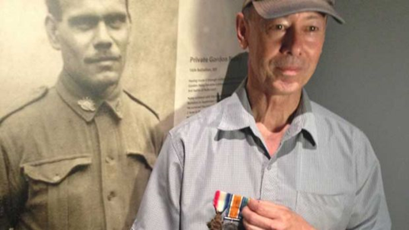

*Gordon Charles Naley and Michael Laing*

"Both non Aboriginal and Aboriginal people went to serve in the wars together and they were mates, they were all on the same level and had the same respect for each other and same friendship and I think that's the real Anzac spirit isn't it?"

These are the words of Michael Laing, the grandson of Gordon Charles Naley, an indigenous soldier who fought as part of the 16th Battalion in World War One.

It was only fitting that Mr Laing spoke about the Anzac spirit while in the West Australian city of Albany on the weekend, where tens of thousands of visitors converged to commemorate the departure of the first Anzac convoy 100 years on.

Mr Naley was part of the second Anzac convoy, he boarded the HMAT Ceramic on December 22, 1914 in Melbourne, which made its way to Albany, which ended up being the last sight of Australian land for those on board for some time.

His people inhabited the Nullarbor region across Western Australia and South Australia.

"Grandfather grew up there living and working on the stations, doing shearing, horse breaking, doing all sort of things like that," Mr Laing said.

"He enlisted in Morphettville in South Australia in late 1914."

Mr Naley served in Gallipoli and the Western Front.

As he died years before his grandchildren were born, from what were believed to be complications from him being gassed while serving in France- what Mr Laing knows of him comes from what he's been told from others.

"My knowledge of my grandfather is sort of like a composite story of different people giving me bits and pieces about my grandfather," Mr Naley said.

"My mother talked about him, my uncles, did, my aunties did, also people who knew grandfather, who met him and spoke to him, people in the country had little stories to tell, personal stories to tell, some funny, some interesting but also his service record, I was able to look at."

He said he could only guess at what his grandfather's motivations were to enlist for war but said he would think that his motivations were similar to those of non-Aboriginal people.

"Around about that time he was starting to include in his friendship group, a lot of non- Aboriginal people, during the course of his work and employment and that, obviously he'd meet non Aboriginal people on stations and things like that.

"I can only guess when the war started up he'd formed some close friendships and caught up with the spirit of it all, probably that's how it happened.

"I honestly don't think that he would've been treated any differently, the friends that he had before the war and after the war, those friendships carried through, I don’t think he would've even gone if he didn’t have that connection there."

He said meaningful relationships like those his grandfather formed were one of the more genuine forms of reconciliation in Australian society.

"There are a lot of stories of Aboriginal soldiers and people being treated the same as non-Aboriginal people and having really good mates and I think reconciliation in a sense is on a much smaller level but on a strong level, maybe it needs to be as strong as that in a higher level," Mr Laing said.

"That Anzac spirit is an amazing spirit we have here in Australia, I hope it never dies, I think we all get something out of it and I hope for future generations they continue to carry it long after we are gone too."

The personal story of Gordon Charles Naley is one of 32 told at the National Anzac Centre in Albany which was officially opened by the Prime Ministers of Australia and New Zealand on Saturday.

The final day of a four day program of events marking the centenary of the departure of the first convoy for World War I will take place in Albany on Sunday.

***This information is what you need to find!***

1. *The soldiers name:*
2. *Where the soldier was from state, city/town:*
3. *Family history:*

*(ie. parents, siblings, wife, children etc).*

1. *Work/Study history:*

*(ie. what they did before the war).*

1. *What the soldier did during the war:*

*(ie. what they may be famous for).*

1. *Where the soldier served and rank:*

*(ie. names of countries, locations, battles etc).*

1. *What is the significance of the soldier’s service:*
2. *Did the soldier survive the war:*

*(Length of service, location of death).*

1. *What did the soldier achieve after the war:*

*(Career).*

1. *Additional interesting information about the soldier:*